September 2025
Application for the cancellation of a mineral claim or opal prospecting licence within the Lightning Ridge Mineral Claims District

Form LR1 Mining Act 1992

When to use this form
Use this form if you hold a mineral claim or opal prospecting licence granted under the Mining Act 1992 within the Lightning Ridge Mineral Claims District and you want to request the cancellation of a small-scale title.
This form has been prepared in accordance with the requirements of Part 9, section 203 and section 233 of the Mining Act and the Mining Regulation 2016. If there is insufficient room in any of the fields, please provide the information as an attachment.
Any reference to the ‘department’ in this form refers to the Department of Primary Industries and Regional Development.

Privacy statement
View the department’s Privacy Statement on how information in this application will be used: www.resources.nsw.gov.au/privacy-statement.

How to lodge
Completed applications with all supporting evidence can be lodged:
- By email: Send an electronic copy of your form, including any attachments, to lightningridge.office@regional.nsw.gov.au
- By mail: NSW Resources, Title Assessments, PO Box 314, Lightning Ridge NSW 2834
- In-person: at the department's office, 41 Opal Street, Lightning Ridge, NSW, between the hours of 9.30 am to 1:00 pm and 2:00 pm to 4:00 pm on Monday to Thursday or 9:30 am to 1:00 pm on Friday
Lodgement of your form in this manner is taken to be lodgement with the Secretary under the Mining Act.
For help completing or lodging this form, contact the NSW Resources Small Scale Titles team on the contact details above or phone: +61 2 6820 5200.

Important notes

Accompanying documentation
Applicants must bring proof of identity documentation, such as a valid driver's licence for sighting and verification by Lightning Ridge Office staff. The proof of identity document must include your name, date of birth, address, photograph and signature. If any details on your proof of identity document do not match the details provided in this form (e.g. address), then an explanation is to be provided. Further evidence may be requested by the department.
Only completed applications with all supporting information or documents will be accepted by the department. Your application may be rejected if you do not supply the required information or documents to the department (see section 381B(1)(b) of the Mining Act).

Agents
If this application is lodged by an agent on behalf of the applicant(s), you must provide evidence that the agent has authority to act on behalf of the applicant. This can be done by completing the declaration at the end of this form and supplying evidence of their appointment (clause 97 of the Mining Regulation 2016). If this information is not provided, the decision-maker may reject the application.

Next steps
Once your application has been received, it will be assessed by the department. The department will notify you in writing of the outcome of your application.

- Details of the mineral claim or opal prospecting licence to be cancelled
Mineral claim |  | Opal prospecting licence (OPL)
Mineral claim number |  | OPL number
Expiry date |  | Block number
Whole area of mineral claim? | Yes  No – go to 1.1 | Expiry date
  - Mark-out diagram showing parts of the mineral claim to be cancelled and retained
Attach a mark-out diagram showing the area you want to cancel. The diagram must show the distance and bearing to each side of the claim area and a survey mark.
- Holder(s) details
Holder details
Name or company name | Proof of identity document (e.g. valid drivers licence) is attached
Australian Company Number (if a company is applying)
Name(s) of all company director(s) (if company is applying)
Contact person (if a company applying) | Proof of identity document (e.g. valid driver’s licence) is attached
Contact phone
Contact email | The department’s preference is to communicate with you and to serve any correspondence, notices, and documents by email. Would you like to nominate your above email address for communications and service?  Yes No
Street address (Registered street address for a company)
Postal address | Same as above
  - Additional holder's details
If there is more than one holder, please provide their details as required in Question 2 as an attachment to this application.
- Rehabilitation
Mineral claims and opal prospecting licences must be rehabilitated.
Any liability incurred by the holder before the title ceased to have effect continues following cancellation, including the requirement for rehabilitation. A notice may be issued under s240 directing the claim holder or former claim holder to rehabilitate the land. By not rehabilitating the claim area, any security bond held against the claim area may be forfeited to the Crown pursuant to s261F(3) or (3A). The department may take enforcement action against a person who does not comply with a direction. Under s241(2), the department may seek to recover any costs or expenses incurred by the Crown in rehabilitating the claim area.
Question | Response
Is the small-scale title within a preserved mining field? | Yes  No
Were opal mining or prospecting activities undertaken on this title? | Yes, complete all questions in this application  No, move on to Question 10
Date rehabilitation activities were completed on? | (dd/mm/yy)
- Rehabilitation of mine shafts and auger holes
Mine shafts are primarily shafts for access. Auger holes are primarily holes for ventilation.
  - Were there mine shafts on the small-scale title?
Yes. How many? | No
  - Were there auger holes drilled on the small-scale title?
Yes. How many? | No
  - What rehabilitation has been undertaken for mine shafts and/or auger holes?
I confirm the following rehabilitation activities have occurred |  | Yes | No | NA
All mine shafts have been backfilled with mullock
Mullock has been heaped over the centre of the backfilled mine shaft at a height of no greater than one to 2 metres
All auger holes have been backfilled
Drill cuttings have been heaped over the centre of the backfilled auger hole at a height of approximately 300 mm in a circle of no more than one metre in diameter
Drill cuttings that have been heaped over backfilled auger holes are covered with approximately 50 mm of red gravel
If you answered no in this table, provide reasons as to why this has not been completed
- Removal of mullock, soil and vegetation stockpiles
Details of rehabilitation activities |  | Yes | No
Excess mullock been removed through transporting to a designated mullock dumps.
Topsoil has been respread over disturbed areas on-site.
Vegetation has been spread over disturbed areas on-site.
If you answered no in this table, provide reasons as to why this has not been completed.
- Environmental management
I confirm the following rehabilitation activities have occurred for the site: |  | Yes | No
The site has been left in a clean and tidy condition
All on-site rubbish has been disposed of at a lawful facility
All on-site mining-related infrastructure (e.g. plant, equipment, shipping containers, vehicles, buildings, structures, tools) has been removed
There are no obstructions or interference to surface water flows in any stream or watercourse
The state of disturbed and rehabilitated areas is compatible with the surrounding land uses
If you answered no in this table, provide reasons why this has not been completed
If you hold or held:
- a Mineral Claim with Restricted Mining Operations approval, go to question 7.
- a Class D (puddling), E (mullock stockpiling), or G (open cut mining) Mineral Claim, go to question 8 .
If not, go straight to question 9.
- Rehabilitation of mineral claim with a restricted operations approval
  - Is the small-scale title a mineral claim that has been issued a s175 restricted operations approval (e.g. a trenching permit)?
Yes | No. Go to Question 9
  - Were there any trenches excavated on the small-scale title?
Yes. How many? | No
  - What rehabilitation has been undertaken for excavated trenches?
I confirm the following rehabilitation activities have occurred |  | Yes | No
All excavated trenches have been backfilled with mullock
Backfilled trenches do not obstruct surface water flows
Topsoil with subsoil underneath has been spread over the backfilled trench
If you answered no in this table, provide reasons why this rehabilitation has not been completed.
  - Has the site been rehabilitated following the claim’s approved mining operations plan?
Yes |  | No
If you answered no, provide reasons for not rehabilitating in accordance with the Mining Operations Plan
- Rehabilitation of Class D (puddling), Class E (mullock stockpiling), Class G (open cut mining) mineral claims
  - Is the small-scale title a Class D, Class E or Class G mineral claim?
Yes | No. Go to Question 9
  - Has the site been rehabilitated following the claim’s approved mining operations plan?
Yes |  | No
If you answered no, provide reasons for not rehabilitating in accordance with the Mining Operations Plan

- Other rehabilitation activities
  - Has there been any other additional rehabilitation activities undertaken on the small-scale title that have not been outlined in this application?
No – Go to Question 10
Yes.
If yes, please provide details:
- Diagram of small-scale title area
Please draw your small-scale title shape in the following box and identify it using the symbols provided below. Please note the numbers corresponding to the photographs provided as evidence on this diagram. (If you are completing this form for an OPL, office staff can provide a map.)


Unsecured shaft |  | Tracks
Secured shaft |  | Topsoil stockpiles
Auger holes |  | Excessive disturbance areas
Mullock stockpile |  | Structures
- Photographs of the small-scale title area
You must provide photographs demonstrating the current state of the small-scale title area, including any disturbed and/or rehabilitated areas. The photographs must provide evidence that you have adequately undertaken rehabilitation activities. If no mining and/or prospecting activities were undertaken on the small-scale title, photographs must still be provided to demonstrate the state of the area.
As a minimum, the photographs must include the following:
- For a mineral claim, there must be a photograph taken from every marker post (i.e. corner peg) looking into the centre of the claim. See below example. You must note the numbers corresponding to the photographs in your diagram above in question 10.
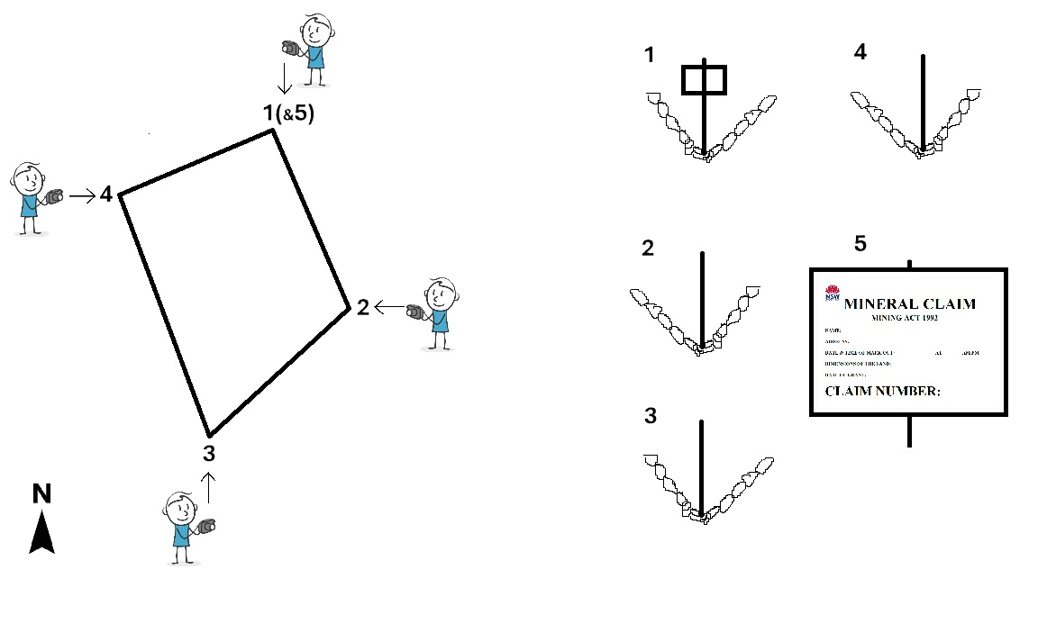
- For an opal prospecting licence, there must be a photograph of every hole drilled.
- If mine shafts or auger holes were utilised, a photograph of where each individual mine shaft or auger hole was located.
- Where any other disturbance, including mining infrastructure, noted on the diagram in question 10, a photograph showing the current state.
Additionally, the photographs must meet the following minimum requirements:
- Good quality colour images which are of an easily visible size.
- Clear and focused images.
- Labelled with a reference number that corresponds to the reference number used on the diagram/map.
Please attach your photographs to this application and fill in the table below. If you have more photographs, please provide details on a separate page.
Reference number | Description of photograph and any relevant details (e.g. GPS coordinate of OPL drill hole) | Date taken  (dd-mm-yyyy)
- Return of security deposit (if applicable)
Provide your bank details and attach proof of ownership (e.g. bank letter or bank statement) of the nominated bank account so that the department can return your security deposit if eligible.
Bank details for the return of the security deposit
Bank name
Account name
BSB
Account number

- Checklist of items to be included with this application
Complete the checklist below before signing the declaration.
Items to be attached to the application | Yes | N/A | Reference
Mark-out diagram showing parts of the mineral claim to be cancelled and retained |  |  | Question 1.1
Proof of identity (e.g. valid driver’s licence) |  |  | Question 2
Additional holder details and proof of identity document (e.g. valid driver’s licence) |  |  | Question 2.1
Photographs of the small-scale title area |  |  | Question 11
Evidence of bank details (e.g. copy of bank statement) |  |  | Question 12
Additional holders’ declaration |  |  | Question 14.2
For agents only, written evidence of appointment and proof of identity (e.g. valid driver’s licence) |  |  | Question 15
- Declaration of applicant
  - Applicant(s) (individual or company)
This section is to be completed by the holder(s) applying for the cancellation of a mineral claim or opal prospecting licence.
Each holder (or authorised representative of a company) must complete the declaration below and sign this form:
- I certify that the information provided is true and correct to the best of my knowledge and belief. I understand under the Crimes Act 1900 NSW Part 5A, that knowingly or recklessly giving false or misleading information is a serious offence, and under the Mining Act section 378C, any person who provides information that the person knows to be false or misleading is guilty of an offence, for which they may be subject to prosecution.
- I agree to notify the department immediately of any changes to the information in this form or the documents provided with this application.
- I acknowledge that failure to provide all required information and documents may result in delays in processing the application or refusal of the application.
- (For companies only) I declare that I am authorised to complete and lodge this application
Holder details
Name or company name
Contact person and their position (for companies only)
Date
Signature
  - Additional small-scale title holders
If there is more than one holder of the small-scale title, please provide their signed declaration as an attachment. The attachment must be a copy of Question 14.1 where each additional holder has filled in their name, date and has signed.
- Declaration of agent authorised to act for this applicant(s) (if applicable)
As the small-scale title holder, you can appoint an agent if desired. An agent can lodge an application on your behalf. You will need to provide written notice that you have appointed a person as your agent.
The authorised agent must complete the declaration below and sign this form:
- I certify that the information provided is true and correct to the best of my knowledge and belief. I understand under the Crimes Act 1900 NSW Part 5A, that knowingly or recklessly giving false or misleading information is a serious offence, and under the Mining Act 1992 section 378C, any person who provides information that the person knows to be false or misleading is guilty of an offence, for which they may be subject to prosecution.
- I agree to notify the department immediately of any changes to the information in this form or the documents provided with this application.
- I acknowledge that failure to provide all required information and documents may result in refusal of the application.
- I declare that I am authorised to complete and lodge this application.
Agent details
Name | Proof of identity document (e.g. valid driver’s licence) is attached
Contact phone
Contact email | The department’s preference is to communicate with you and to serve any correspondence, notices and documents by email. Would you like to nominate your above email address for communications and service?  Yes No
Street address
Postal address | Same as above
Evidence of appointment as an agent | I have attached a written notice by the applicant of my appointment as their agent
Date
Signature

Office use only
Application received
Time: | Date:
Officer’s name:
Signature:

State of New South Wales through the Department of Primary Industries and Regional Development 2025. The information contained in this publication is based on knowledge and understanding at the time of writing (August 2025). However, because of advances in knowledge, users are reminded of the need to ensure that the information upon which they rely is up to date and to check the currency of the information with the appropriate officer of the Department of Primary Industries and Regional Development 2025 or the user’s independent adviser.

