May 2025

Form

# Notification of other matters (including reportable events) for exploration only

## WHS (Mines and Petroleum Sites) legislation

This form is to be submitted in relation to exploration to be undertaken at mines or petroleum sites to notify the Regulator of reportable events.

* As an alternative to submitting this form, reportable events notification can be made online via the [Regulator Portal](https://nswresourcesregulator.service-now.com/regulator) as shown below.

## Notifying via the portal

Select the ‘Operator’s Portal’ from the menu.

**A screenshot of a computer showing the operator's portal

**

Select Operation Notifications

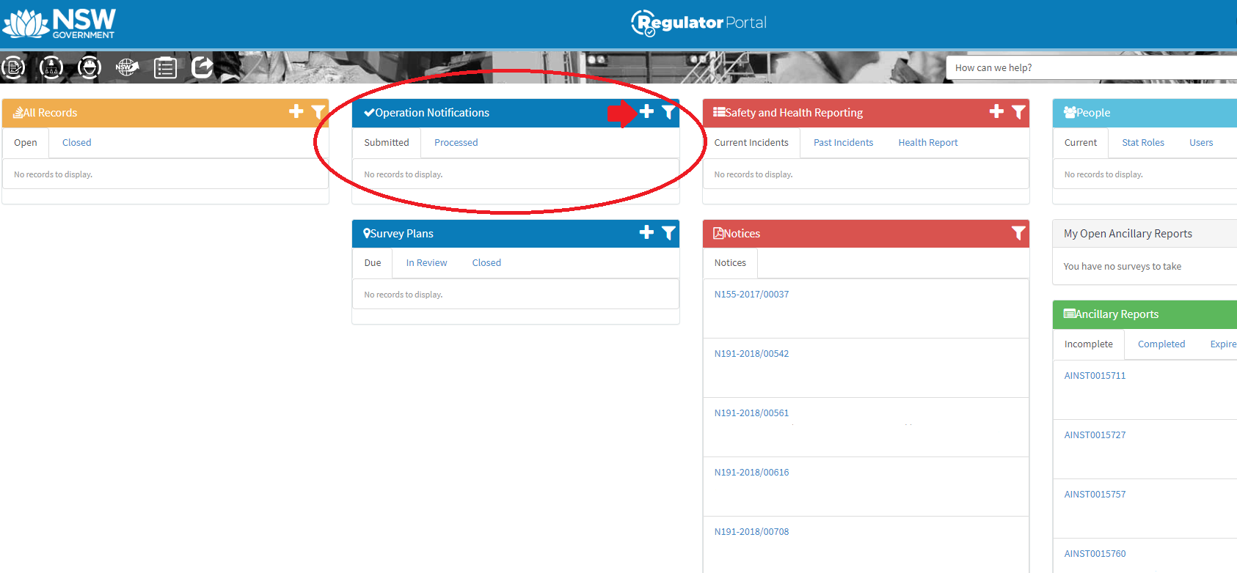

Then select to Operator Appointment or Commencement of Mining depending on the desired notification.

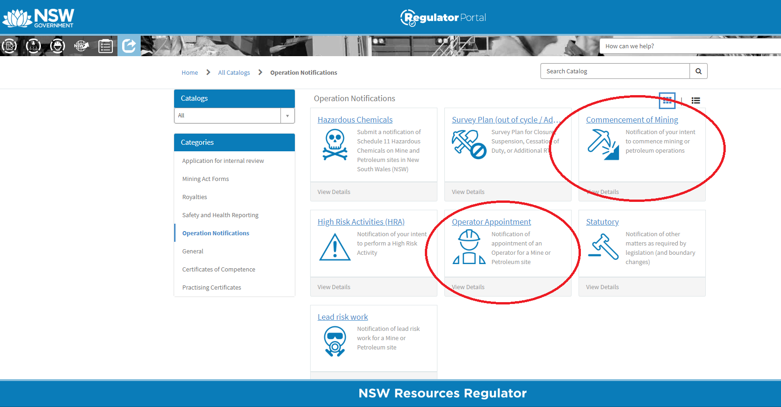

## About this form

Section 125 of the Work Health and Safety (Mines and Petroleum Sites) Regulation 2022 sets out requirements on the operator of the mine or petroleum site undertaking exploration (or prospecting) by ‘mechanical means’ to notify the Regulator of certain events referred to as ‘reportable events’.

In respect of exploration (or prospecting) at a mine or petroleum site these are:

* the commencement of exploration or prospecting by mechanical means
* any significant interruption to, or suspension of, exploration. **Note:** Notification is not required in relation to a significant interruption or suspension if the mine operator has already notified us of the interruption or suspension in relation to an incident referred to in section 124 or a notifiable incident.
* recommencement of normal exploration following an event referred above.
* closure of the exploration site.

Notification is not required for exploration for minerals or petroleum by non-mechanical means - see later in this form for more information.

Penalties apply if the operator of a mine or petroleum site does not comply with section 125 of the Work Health and Safety (Mines and Petroleum Sites) Regulation 2022.

## When to notify

The operator of the mine or petroleum site where exploration by mechanical means that disturb the ground will occur must notify the Regulator of these events before the event occurs except:

* if the operator did not intend for the event to occur and could not have foreseen the event occurring, in this case notice must be given as soon as practicable after the event occurs.

## Mechanical and non-mechanical means of exploration

**It is not necessary to notify the Regulator of commencement of non-mechanical exploration or prospecting.**

Non-mechanical exploration means, exploring or prospecting for minerals or petroleum (other than by mechanical means, that disturb the ground) and includes the following:

* geological mapping
* sampling and coring using hand-held equipment.
* geophysical surveying (but not seismic surveying) and borehole logging
* access by vehicle (but not if access requires the construction of an access way such as a track or road)
* shallow reconnaissance drilling involving no more than minimal site preparation.
* minor excavations (but not costeaning or bulk sampling).

**Exploration or prospecting by mechanical means that disturb the ground must be notified.** Exploring for minerals or petroleum by mechanical means that disturb the ground includes:

* drilling (other than the use of hand-held augurs for sampling and coring or shallow reconnaissance drilling involving no more than minimal site preparation)
* seismic surveying
* costeaning or bulk sampling
* construction of access ways or roads.

## Changes to a drilling program

A single notification may be submitted for a series of drilling activities at an exploration site. However, if there are significant changes to the planned drilling program such that the submitted notification does not reflect the drilling program, a new notification must be submitted.

1. Mines and petroleum exploration sites
   1. Details of operator and site

|  |  |  |  |
| --- | --- | --- | --- |
| **Operator and site details** | | | |
| Name of operator for the exploration site |  | | |
| ACN is a company or ABN |  | | |
| Title of exploration licence (e.g., EL number) |  | | |
| Site address |  | | |
| Postal address |  | | |
| Suburb |  | Postcode |  |

* 1. What are you notifying?

|  |  |
| --- | --- |
|  | Commencement of exploration |
|  | Significant interruption to, or suspension of, exploration  (Please describe the reasons for the interruption or suspension of exploration as well as any operations that are continuing at the exploration site. Attach additional information if required) |
|  | Recommencement of normal exploration |
|  | Closure of the exploration site (e.g., when all rehabilitation is completed) |

1. Details of exploration

If notifying the Regulator of any proposed material change to information previously supplied, sections 2 and 3 must be completed, but any fields where the information has not changed may be left blank.

|  |  |  |
| --- | --- | --- |
| **Exploration site** | | |
| Proposed date of commencing exploration. |  | |
| GPS co-ordinates of the area covered by the exploration. |  | |
| Provide details of the scope, character, and location of the exploration |  | |
| What minerals or petroleum are being explored? | Coal  Petroleum | Other mineral or quarry product |

1. Declaration

I declare that:

* I have authority from the mine operator / petroleum site operator to complete and submit this form on their behalf.
* to the best of my knowledge, the information provided in this form, and any attachment to this form, is true and correct in every detail.

|  |  |  |  |
| --- | --- | --- | --- |
| **Note: Giving false or misleading information is a serious offence under section 268 of the *Work Health and Safety Act 2011*, and Part 5A of the *Crimes Act 1900*** | | | |
| Name |  | | |
| Position/title |  | | |
| Email address |  | | |
| Postal address |  | | |
| Suburb |  | Postcode |  |
| Telephone |  | Mobile |  |
| Signature | 1st Applications Signature | Date |  |

## Submitting the form

Email this form to [cau@regional.nsw.gov.au](mailto:cau@regional.nsw.gov.au) (or other email address as applicable)

Mail: Central Assessment Unit, Resources Regulator, PO Box 344, HRMC, 2310.

© State of New South Wales through the Department of Primary Industries and Regional Development 2025. You may copy, distribute, display, download and otherwise freely deal with this publication for any purpose, provided that you attribute the Department of Primary Industries and Regional Development as the owner. However, you must obtain permission if you wish to charge others for access to the publication (other than at cost); include the publication in advertising or a product for sale; modify the publication; or republish the publication on a website. You may freely link to the publication on a departmental website.

Disclaimer: The information contained in this publication is based on knowledge and understanding at the time of writing (May 2025) and may not be accurate, current or complete. The State of New South Wales (including Department of Primary Industries and Regional Development), the author and the publisher take no responsibility, and will accept no liability, for the accuracy, currency, reliability or correctness of any information included in the document (including material provided by third parties). Readers should make their own inquiries and rely on their own advice when making decisions related to material contained in this publication.